INFSCI 2725: Data Analytics

Assignment 6

Jinrong Liu, Fengxi Liu

1. Chocolate consumption, cognitive function, and Nobel laureates

We replicate the analysis from the article. Data on chocolate consumption in kg per capita per year in 22 countries was obtained from Caobisco (<http://www.theobroma-cacao.de/wissen/wirtschaft/international/konsum)>. Data on the number of Nobel Laureates per 10 million population in 22 countries was obtained from Wikipedia (<https://en.wikipedia.org/wiki/List_of_countries_by_Nobel_laureates_per_capita)>.

We generated the scatter plot and did a linear regression data analysis.



The result indicates that the there was a close, significant linear correlation between chocolate consumption per capita and the number of Nobel laureates per 10 million persons in a total of 22 countries. Switzerland had the highest chocolate consumption and had the second most Nobel laureates (the first is Sweden, which is only 0.552 more than Switzerland in average). And we notice that although Sweden had the most Nobel laureates, it merely had an amount of 4.4kg chocolate consumption, which is less than half of the chocolate consumption of Switzerland. We agreed with the opinion that was came up with from the article, which is that the Nobel Committee in Stockholm has some inherent patriotic bias when assessing the candidates for these awards, or perhaps that Swedes are particularly sensitive to chocolate so that even minuscule amounts greatly enhance their cognition.

Besides the opinion from the article, we think that there might be other factors that can influence the result such as alcohol consumption and coffee consumption, so we did an analysis in terms of these two factors as well.

1. Alcohol consumption and Nobel laureates.

Data on pure alcohol consumption among adults (age 15+) in liters per capita per year (2010) in 22 countries was obtained from Wikipedia (<https://en.wikipedia.org/wiki/List_of_countries_by_alcohol_consumption_per_capita>).



Because dietary flavonoids are abundant in red wine, according to the research about the chocolate consumption, we assume that higher alcohol consumption will be corresponding to more Nobel laureates, but the scatter plot and the regression data analytic result above shows a different result. There was only a weak linear correlation (r = 0.1094, p = 0.6278) between alcohol consumption and Nobel laureates. We notice that the data also has more detailed information, there are percentage about beer, wine, and spirits consumption separately. What we really interested in should be the wine consumption. So we did another analysis base only on the wine consumption.



According to the regression analysis, we find that here r = 0.3141 and p = 0.1545, which also indicates that wine consumption does not have a necessary relationship with the number of Nobel laureates. Considering this, one reason might be that there are hundreds of wine types in the world, some types of wine may rich in dietary flavonoids while others not, and the type of wines consumption may vary in different countries.

To do some further research, we find the data of coffee consumption as well and want to find out if there is a linear correlation between coffee consumption and the number of Nobel laureates.

1. Coffee consumption and Nobel laureates.

Data on the coffee consumption in kg per capita per year in 21 countries was obtained from Wikipedia (<https://www.google.com/fusiontables/DataSource?docid=1C-fn6nSe21acP0xJIO1T1x0wohqfMYCQyJjbqdk#rows:id=1)>. We eliminate China here because we did not find the data of China.



From the regression analysis we can see that r = 0.3927 and p = 0.0782, we cannot say that there exists a significant linear correlation between coffee consumption and the number of Nobel laureates. But why does chocolate consumption and the number of Nobel laureates have a such close linear correlation while others not? According to that article, we should know that a correlation between X and Y does not prove causation but indicates that either X influences Y, Y influences X, or X and Y are influenced by a common underlying mechanism. We think it is true that it should remain to be determined that whether chocolate consumption enhances cognitive function, and that the cognitive function is a common underlying mechanism between chocolate consumption and the number of Nobel laureates.

1. R plot

We are trying to analyze these factors using R as well.

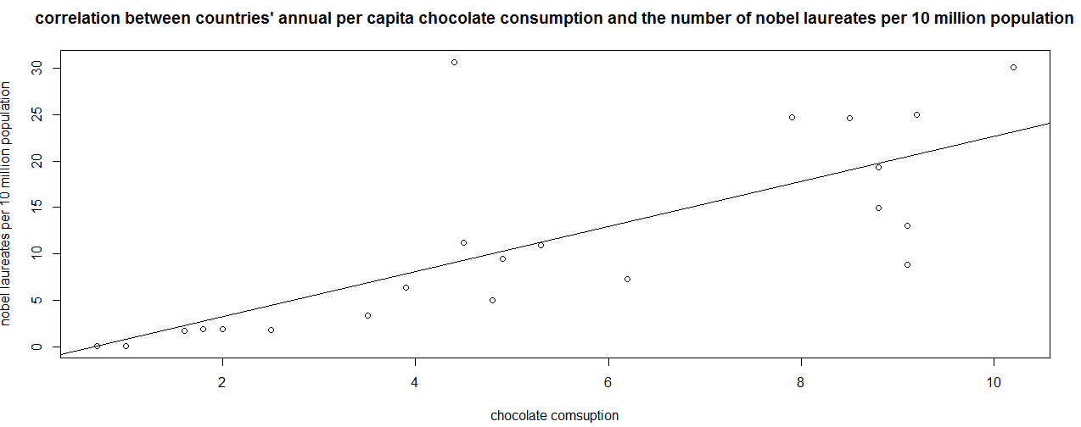

ERE:

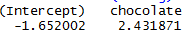

Y=-1.652002+2.431871\*x

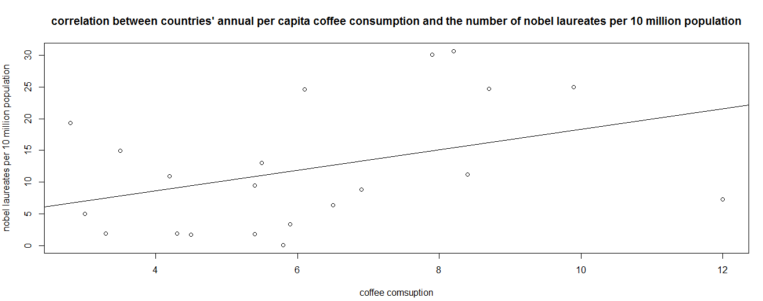ERE:



Y=2.099790+1.623701\*x

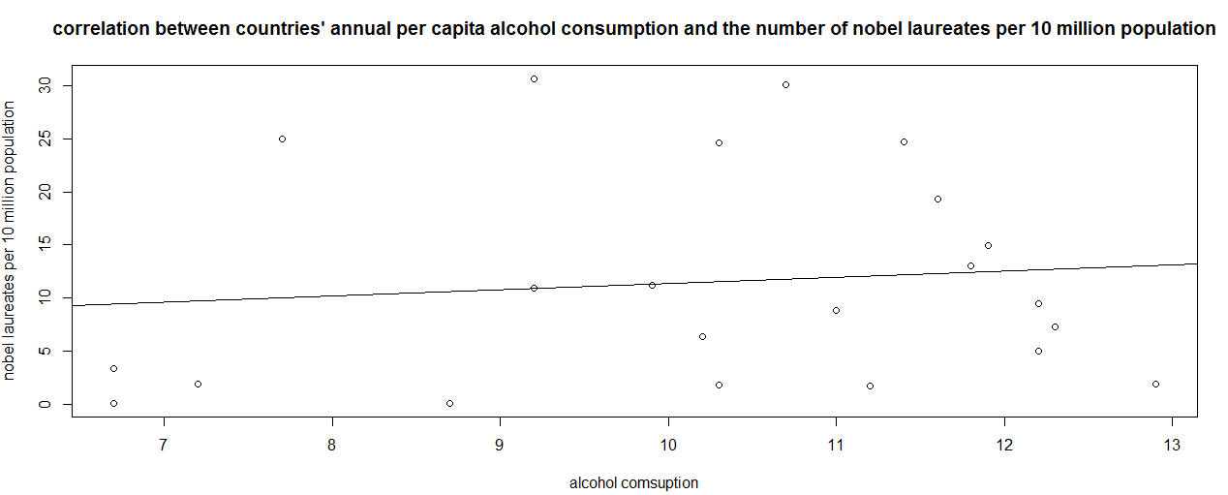

EME:



Y=5.4998085+0.5828816\*x

R script:

1.

plot(data=nobel,Nobel.Laureates.10.million~chocolate,main="correlation between countries' annual per capita chocolate consumption and the number of nobel laureates per 10 million population",xlab="chocolate comsuption",ylab="nobel laureates per 10 million population")

lm.reg<-lm(data=nobel,Nobel.Laureates.10.million~chocolate)

abline(lm.reg)

coefficients(lm.reg)

2.

plot(data=nobel,Nobel.Laureates.10.million~coffee,main="correlation between countries' annual per capita coffee consumption and the number of nobel laureates per 10 million population",xlab="coffee comsuption",ylab="nobel laureates per 10 million population")

lm.reg2<-lm(data=nobel,Nobel.Laureates.10.million~coffee)

abline(lm.reg2)

coefficients(lm.reg2)

3.

plot(data=nobel,Nobel.Laureates.10.million~alcohol,main="correlation between countries' annual per capita alcohol consumption and the number of nobel laureates per 10 million population",xlab="alcohol comsuption",ylab="nobel laureates per 10 million population")

lm.reg3<-lm(data=nobel,Nobel.Laureates.10.million~alcohol)

abline(lm.reg3)

coefficients(lm.reg3)